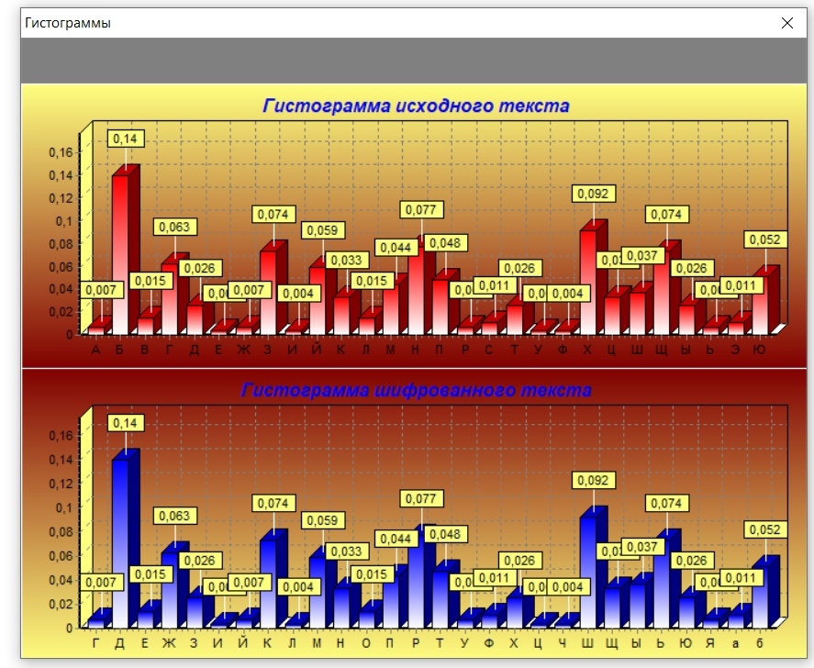

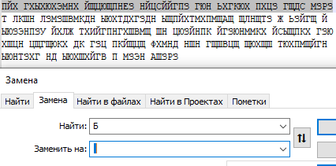

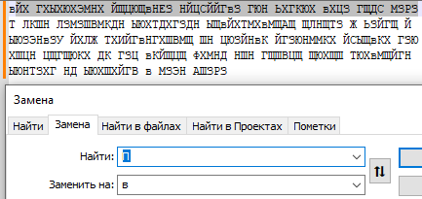

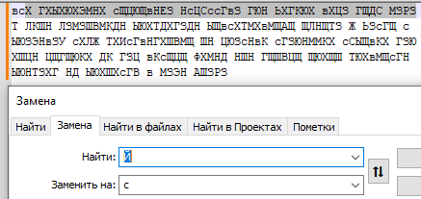

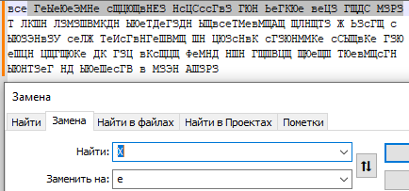

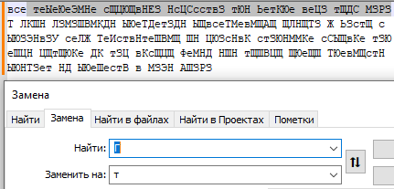

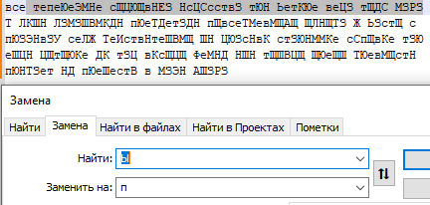

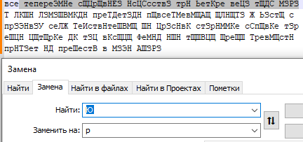

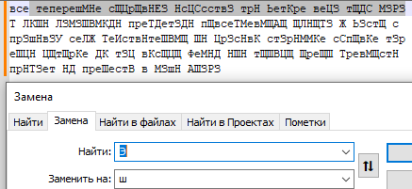

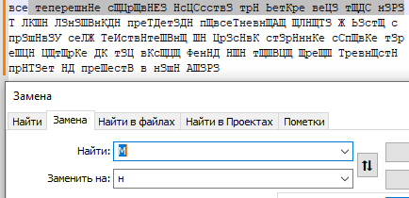

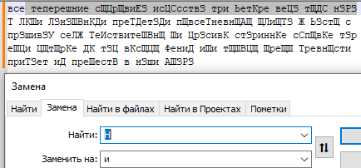

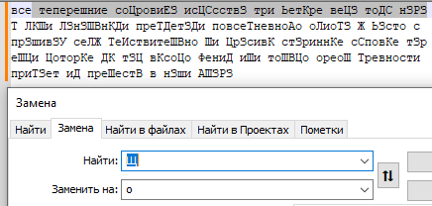

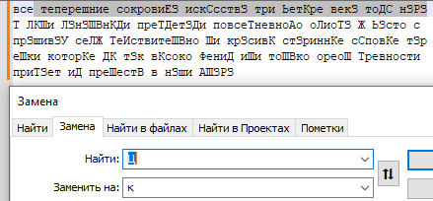

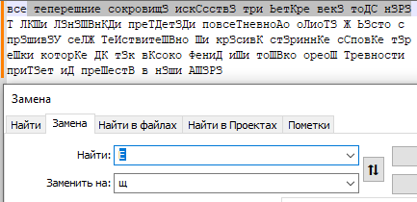

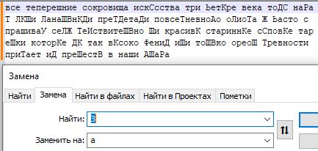

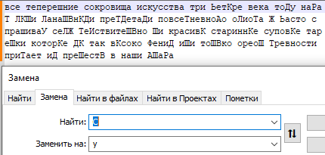

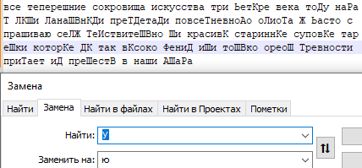

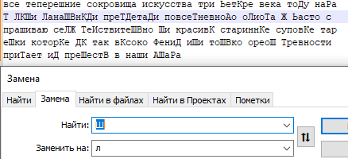

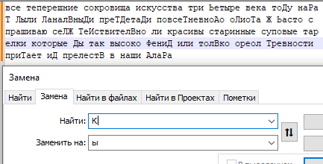

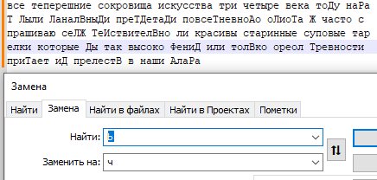

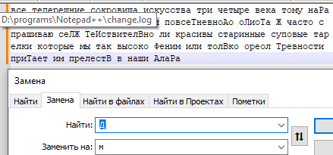

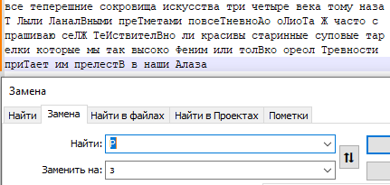

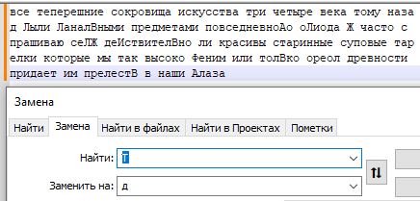

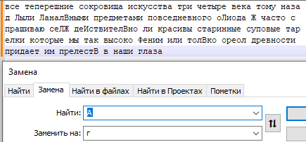

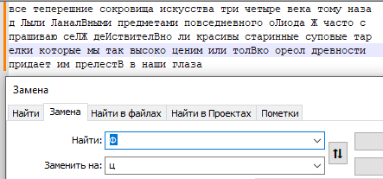

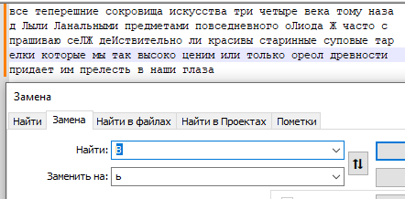

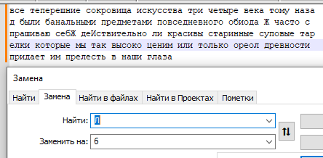

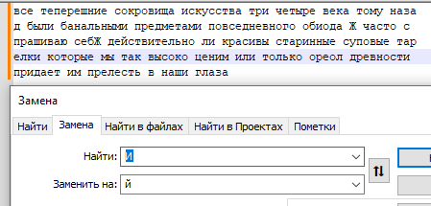

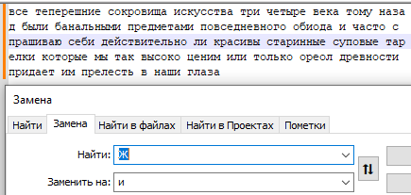

|  |  |
| --- | --- |
| 0.007380073800738007 | г |
| 0.14022140221402213 | пробел |
| 0.014760147601476014 | ь |
| 0.06273062730627306 | т |
| 0.025830258302583026 | м |
| 0.0036900369003690036 | щ |
| 0.007380073800738007 | и |
| 0.07380073800738007 | а |
| 0.0036900369003690036 | й |
| 0.05904059040590406 | с |
| 0.033210332103321034 | ы |
| 0.014760147601476014 | б |
| 0.04428044280442804 | н |
| 0.07749077490774908 | и |
| 0.04797047970479705 | в |
| 0.007380073800738007 | з |
| 0.01107011070110701 | у |
| 0.025830258302583026 | д |
| 0.0036900369003690036 | ю |
| 0.0036900369003690036 | ц |
| 0.09225092250922509 | е |
| 0.033210332103321034 | к |
| 0.03690036900369004 | л |
| 0.07380073800738007 | о |
| 0.025830258302583026 | п |
| 0.007380073800738007 | ч |
| 0.01107011070110701 | ш |
| 0.05166051660516605 | р |